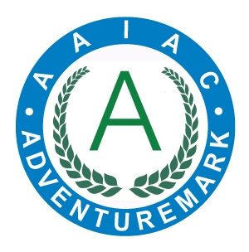
ADVENTUREMARK
www.adventuremark.co.uk
MENDIP ACTIVITY CENTRE
Has met the necessary standards for the safe delivery of
adventure activities as defined by the
Adventure Activities Industry Advisory Committee.

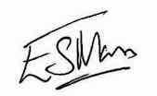
Elspeth Mason, Chair (AAIAC)

Abseiling | Low Ropes Courses
Archery | Mine Exploration
Artificial Climbing Wall | Orienteering
Assault Course | Rock Climbing
Bushcraft | Sit on Top Kayaking
Canoeing | Sledging
Caving | Snowsports
Crate Stacking | Stand Up Paddle Boarding
Hill Walking | Survival Skills
Improvised Rafting | Team Building
Kayaking | Wild Camping

Date Issued : 8th December 2024 Expiry Date : 8th December 2026

Certificate No : AAA101221

